

**Traveling guidelines and practical info**

**”BenchValue” project meeting**

04-06/9/2018;

Best Western Santakos Hotel

Kaunas,

**Hotel Best Western Santakos Hotel**

J. Gruodžio g. 21, Kaunas, LT-44293, Lithuania

<http://santakahotel.eu/EN/Best-Western-in-Lithuania/Kaunas>

[office@santakahotel.eu](mailto:office@santakahotel.eu)

[+370 37 302702](tel://+370%2037%20302702)

20 places are pre-booked for the “Benchvalue” conference participants. The conference will take place in the same hotel. When ordering the room name the order password: benchvalue and order via email [office@santakahotel.eu](mailto:office@santakahotel.eu). Phone reservation is not possible. The hotel room prices are between 52-62 EUR depending on the room type. Full breakfast, and access to sauna and swimming pool in the morning are included.

**Arrival to Lithuania by plane**

There are two possibilities to come to Lithuania by plane.

*First one to land in Vilnius international airport.* This airport is about 100 km from Kaunas and the conference place.

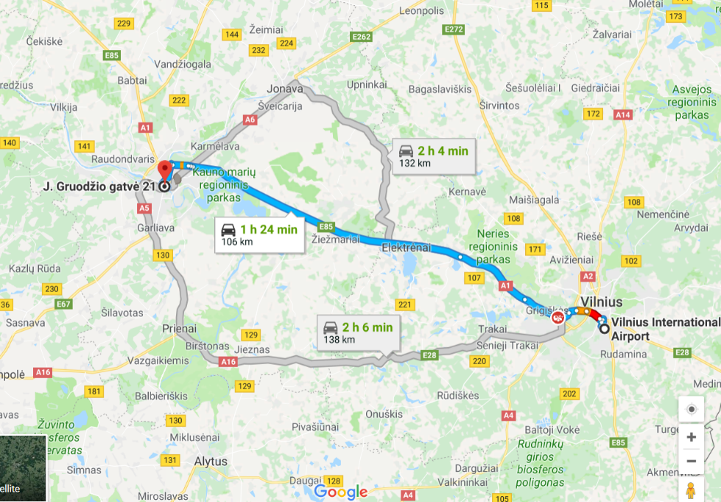

There are several options to reach Kaunas.

Take a taxi at the airport. It is very expensive, because prices are 2-6 times more than ordinary taxi for example in Vilnius.

Second option is to take a train from the airport to the central train station, from there take a train to Kaunas train station (Price about 8 euros). Tickets could be booked here:

<https://traukiniobilietas.lt/portal/en>

Other option is to take a bus from the Vilnius Airport to the bus station, then take a bus to the Kaunas bus station.

From the airport to the bus station take the bus number 1. Timetables are listed here:

<http://www.stops.lt/vilnius/#bus/1/b-a/en>

Also it is possible to take bus no 2.

<http://www.stops.lt/vilnius/#bus/2/b-a/2613/en>

From Vilnius bus station to Kaunas bus station, busses go each 10-15 minutes. So there should not be a problem to find the relevant bus.

<https://www.autobusubilietai.lt/index.php?lang=0&cl=select&fnc=searchByStopId&travel_from=2412-1&travel_to=2408-1>

*The second option is to land to Kaunas international airport.* It is about 22 km from the conference place.

From there take a bus no 29. Taxi are also available

The timetable is here:

<https://www.kvt.lt/tvarkarasciai/kaunas_bus_29>

Go to Kaunas bus station (Autobusu stotis)

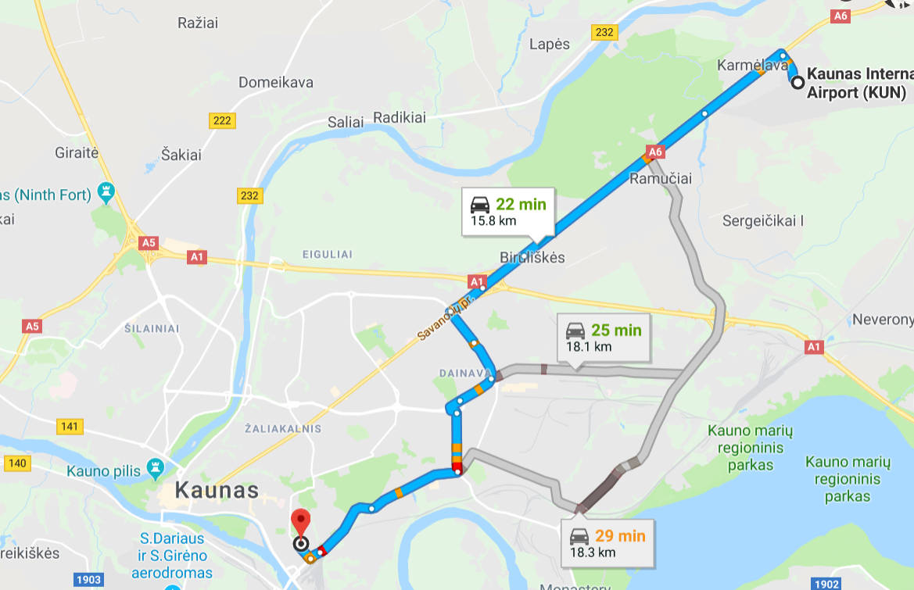

**Reaching Conference place from Kaunas bus and railway stations**

To reach the hotel from the bus station, please take the bus no 14 or no 7.

Timetables are here:

[https://www.kvt.lt/keliones-planuotojas/?origin={%22name%22:%22Autobus%C5%B3%20stotis%22,%22place%22:{%22placeId%22:%22ChIJL3nzbHsi50YRbxWWCt1KGX8%22}}&destination={%22name%22:%22J.%20Gruod%C5%BEio%20g.%2021%22,%22place%22:{%22placeId%22:%22ChIJN01PWwwi50YRMzKs5z6I1rs%22}}&dateTimeOption=departure&dateTime=1528729872934](https://www.kvt.lt/keliones-planuotojas/?origin=%7b%22name%22:%22Autobus%C5%B3%20stotis%22,%22place%22:%7b%22placeId%22:%22ChIJL3nzbHsi50YRbxWWCt1KGX8%22%7d%7d&destination=%7b%22name%22:%22J.%20Gruod%C5%BEio%20g.%2021%22,%22place%22:%7b%22placeId%22:%22ChIJN01PWwwi50YRMzKs5z6I1rs%22%7d%7d&dateTimeOption=departure&dateTime=1528729872934)

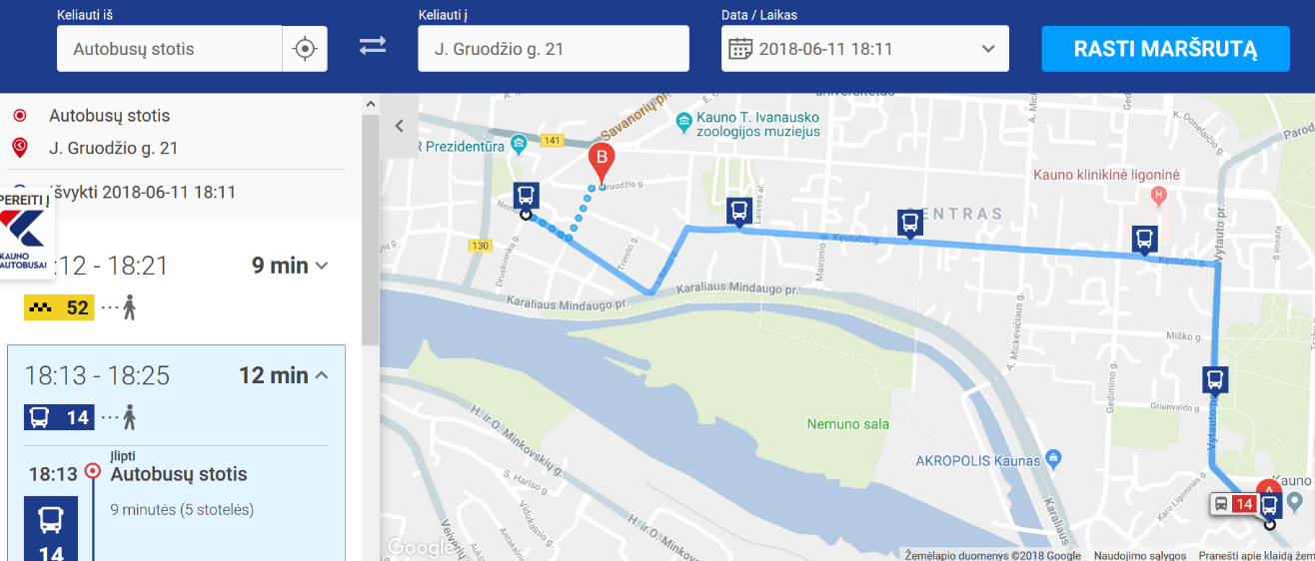

To reach the hotel from the railway station, please take a bus no 1 or no 23.

[https://www.kvt.lt/keliones-planuotojas/?origin={%22name%22:%22Gele%C5%BEinkelio%20stotis%22,%22place%22:{%22placeId%22:%22ChIJfxC1H30i50YRky87JnJ25YI%22}}&destination={%22name%22:%22J.%20Gruod%C5%BEio%20g.%2021%22,%22place%22:{%22placeId%22:%22ChIJN01PWwwi50YRMzKs5z6I1rs%22}}&dateTimeOption=departure&dateTime=1528729872934](https://www.kvt.lt/keliones-planuotojas/?origin=%7b%22name%22:%22Gele%C5%BEinkelio%20stotis%22,%22place%22:%7b%22placeId%22:%22ChIJfxC1H30i50YRky87JnJ25YI%22%7d%7d&destination=%7b%22name%22:%22J.%20Gruod%C5%BEio%20g.%2021%22,%22place%22:%7b%22placeId%22:%22ChIJN01PWwwi50YRMzKs5z6I1rs%22%7d%7d&dateTimeOption=departure&dateTime=1528729872934)

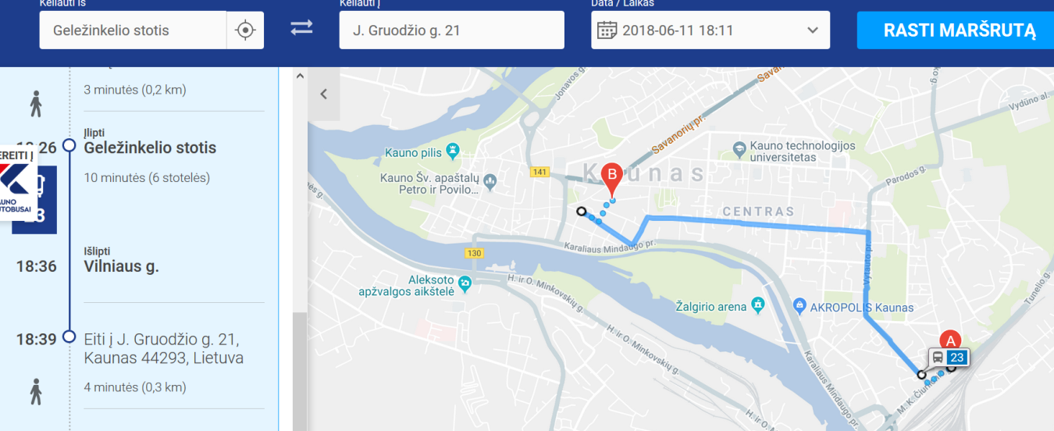

**Currency:**

Euro

For public transport, cash is required.

**Contact details:**

Edgaras Linkevicius +37060875592

Povilas Zemaitis +37060199530